**CHAPTER 1**

**INTRODUCTION**

A variety of software and infrastructure solutions are referred to as cloud products, and although there is not a formal deﬁnition for cloud computing, the solutions tend to have much in common. Most cloud providers, such as Apple, Amazon, Google and Microsoft oﬀer a pay-as-you-go pricing model for software and infrastructure, which is often referred to as a utility pricing model. Many cloud products oﬀer a ﬁnished software solution rather than just infrastructure; for example, Microsoft, Google and Apple oﬀer cloud-based services, such as Hotmail, Gmail and iCloud respectively, directly to end users. The key cloud-based solutions can be divided into three categories: Infrastructure as a Service (IaaS) e.g. virtual machines, Platform as a Service (PaaS) e.g. a managed OS, and Software as a Service (SaaS) e.g. email services. The variety of available cloud-based architectures combined with a utility pricing model makes using a cloud-based architecture applicable to many scientiﬁc and engineering problems.

The study from aerospace engineering to showcase the applicability of a cloud-based architecture. The study looks at the issue of space situational awareness (SSA). SSA involves looking at near Earth objects and understanding the risk they pose to Earth. This has been highlighted in the news by many events including the Upper Atmosphere Research Satellite (UARS) re-entry in 2011, the International Space Station having to perform a collision-avoidance manoeuvre in 2010, and the collision between Iridium-33 and Cosmos2251 in 2009. Figure 1 shows the orbits of these two satellites, and the debris produced by their collision.

The UARS NASA satellite was launched in 1991 as an orbital observatory and its mission was to study the Earth’s atmosphere. UARS was decommissioned in 2005 and in 2010 the International Space Station had to perform a manoeuvre to avoid colliding with this debris. UARS gained considerable attention when it re-entered the Earth’s atmosphere in 2011 with NASA predicting that large parts could reach the Earth’s surface.

The “Clouds in Space” project demonstrated how a cloud-based architecture can be applied to SSA to produce an active debris removal solution. The application of cloud-based architectures to SSA is then discussed in terms of these areas of strength. Detail some of the observations made while architecting, implementing and demonstrating the solution.

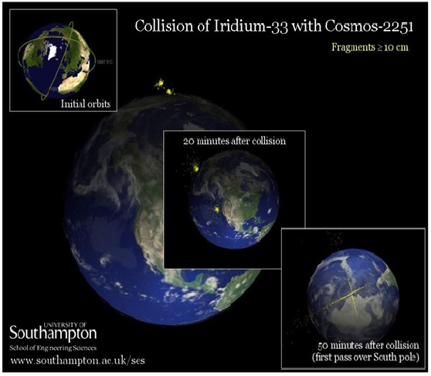

***Fig 1.1:*** *Iridium-33 and cosmos-2251 collision in 2009*